Digital Speech & Debate Video Production Tips

Anthony Trufanov
6/16/2020

1.1 Introduction
Over the past few weeks I’ve been working on a video series about writing an AFF. The underlying premise was that video of card-cutting and block-writing occurring would help underscore the points being made and peel back the curtain on the research process. This guide is written from the perspective of a total video-editing novice. Much of this insight stems from mistakes that I made, some of which I was unable to ultimately fix, but which provided valuable lessons.

Before getting into the weeds, I want to highlight two key ideas that I came away with.

1. Pacing first. Even the best looking and sounding videos will fail if the whole video is conceived in a way that is boring. Aim to make each video no longer than 10 minutes (I overshot here despite my best efforts, but the more important point is that 20 minutes of talking at a slideshow is not compelling). Aim to talk about each sub-concept for no longer than 1-2 minutes. We know intuitively that even debaters don’t have the attention span for a continuous hour of lecturing, even in the best of circumstances; all of the distracting tendencies that contribute to that are exacerbated when they are on YouTube. Narrow your message and get your point across quickly.

2. Always ask why. Each shot should have an answer to the question of why this is a video and not an article or a PowerPoint. If you keep this idea in mind you will force yourself to take advantage of the medium in which you are working to the fullest extent.

1.2 Adobe Premiere
I used Adobe Premiere which I accessed through the UK free software library. Premiere is a component of the Adobe Creative Cloud suite, which is a subscription-based service that costs $20 for the first month and $30 a month after that. Free software can replicate a lot of what Premiere can do, but Premiere is far more comprehensive and versatile, and the subscription comes with a variety of other tools that enable you to do basically anything you can imagine to a video.

The premiere editing window looks like this:

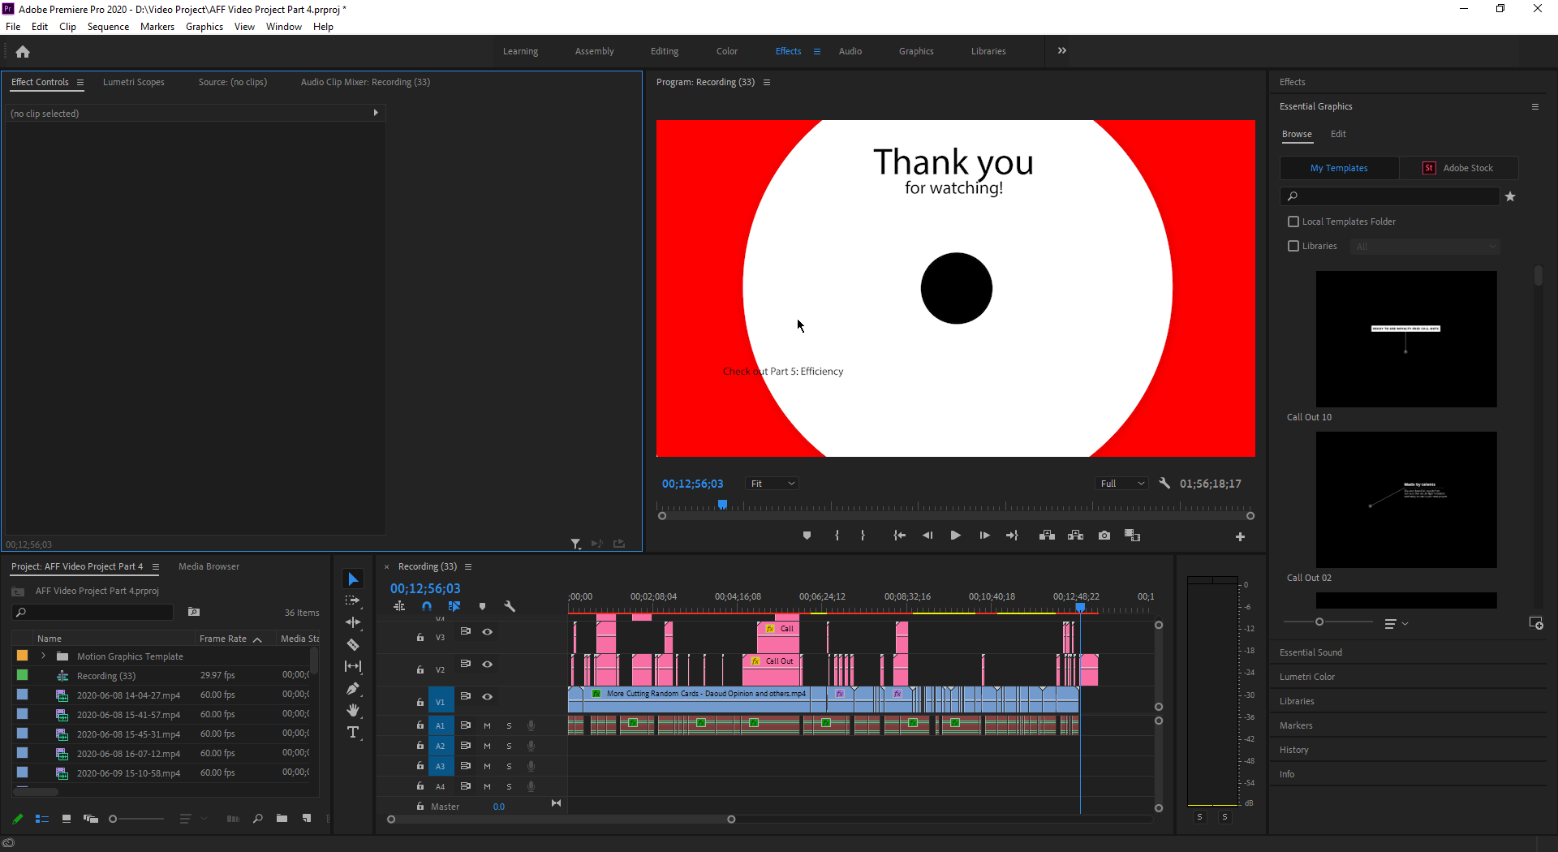

The window arrangement is fully configurable, but there are several key components:

1. Preview pane. Here it is at the middle-top. It is a low-quality render of what you have assembled on the timeline.

2. Timeline. Here it is at the middle-bottom. The timeline is divided into tracks – the bottom are audio tracks, and the top are video tracks. The audio tracks simply combine, whereas the video tracks stack on top of one another. The tracks at the top obscure those at the bottom.

3. Media pane. Here it is at the bottom-left. This is a list of all files that you can or have used in your video project.

4. Effects controls/media preview. Here it is at the top-left. This window lets you control the settings of individual clips – the little bricks on the timeline – and fine-tune the effects you have applied.

5. Effects selection menu. Here it is at the far right. This window lets you choose graphics and insert them into your timeline, or choose effects and modify clips you already have.

1.3 Key Actions
There are several key actions to know to get started.

1. Adding a clip to the video. This could not be simpler – just drag a clip from the media pane to the timeline. The track will show you a preview of where on the timeline it will land and how much space it will take up. Note that placing a track on top of another track will overwrite it. In my project I had a lot of long tracks that I needed to cut down. To do this, I simply inserted tracks after the end of the video on the timeline, cut them down, then moved them into place.

2. Zooming in and out of the timeline. This is kind of counterintuitive at first, but the controls have a logic to them and you will eventually get the hang of it. Click on the circles on either side of the scroll bars and drag them together or apart. Dragging them apart will zoom out. Dragging them together will zoom in.

3. Adjusting the length of clips. There are two ways to do this. First, if you grab the side of a clip, your cursor will show a red bracket. If you drag that red bracket into the clip, you are cropping it. If you drag that red bracket away from the clip, you are revealing parts that were previously cropped away.

Second, between the media pane and the timeline you can see a little menu bar with some icons. The fourth icon down is the razor tool. If you have this tool selected and you click on a clip, you will cut the clip into two pieces at the spot you have clicked. You can cut around parts you want to delete, then select them, and delete them.

4. Applying effects. Effects include literally anything you might want to do to make audio or video look or sound different – volume, equalizer, scaling, cropping, transitions, etc. To do this, look at the effects selection menu. Click effects. Drag the effect you want to the clip you want to modify. Then, if you click the clip and click on the effects controls tab in the media pane, you will be able to fine-tune any of the effects you have applied.

5. Keyframes. Keyframes enable you to control when effects kick in, when they change, and how quickly. This works by you specifying your desired effect state at particular “key frames.” Premiere will then linearly adjust the effect parameter you have selected to fill in what goes in between. For example, I may want one clip to fade out. To do this, I would select a time in the video – let’s say ten before the video ends – and add a keyframe that changes the volume by 0 dB. Then, I would add a keyframe on the last frame of the video that changes the volume by -50 dB. The effect of this would be to reduce the volume by 5 dB per second over the last ten seconds of the video.

You can do this to nearly any effect. If you want to crop a video for part of a shot, then have it gradually expand to reveal the part you cropped out, you would do this by using keyframes and the crop effect. You can do the same thing with positioning or scaling.

In the effects controls tab, you will notice that many of the effects have a little blue stopwatch next to them. That means keyframes are enabled for that effect. Whenever you have a time in your clip selected and you change that effect, you are adding a keyframe. To change the settings for the whole clip, simply click the blue stopwatch, and confirm that you would like to get rid of keyframes.

6. Speeding up video. 1x speed debate work is excruciatingly boring to watch. You will want to speed up most of your videos four or five hundred percent, making sure to cut out dead time. Right click the video clip and select “Speed/Duration…” This will bring up a menu that lets you adjust how long the video takes to play by selecting a percentage value by which to accelerate the video or by choosing the desired duration.

This is far from everything Premiere can do. Fortunately, Premiere has robust tutorials, a huge online community, and lots of articles written about it. You will usually be able to do anything you want if you read about it and play around with the settings.

1.4 Lessons Learned
Many of these hints are likely obvious to someone with any experience in video editing, but not at all obvious if you are just starting out. This is what I have found:

1. Sound equipment. Get a microphone and put it close to your face. If you are going to record video of your face, an external microphone is preferable to a headset because gaming headsets look ridiculous. A clip-on, lapel, or “lavalier” microphone is one easy option, although it risks noisy audio because it is attached to clothes that can rustle. With an external microphone, look into getting a pop filter – that’s basically a little screen that goes between your face and the microphone to prevent your “p” “t” and “k” from overwhelming the sensor.

2. Camera. Avoid your laptop webcam. One of the best ways to cheaply upgrade your video is to use an app that turns your phone into a camera. On iPhones, EpocCam seems to be the best option. On Android phones, Iriun Webcam seems to work well.

3. Screen capture software. OBS Studio is the best one. It allows you to arrange video feeds from a variety of sources however you want. This was how I captured synchronized video of myself typing, or displayed keystrokes on the screen – I simply downloaded an app that shows keystrokes, selected it as a video source, and put it side by side with the feed of the word window.

4. Sound management. The biggest difficulty that I encountered was normalizing the volume across video clips and my voice. The best way to do this is to right click each audio clip, select “Audio Gain…”, select “Normalize All Peaks to:” and then enter a value. Enter the same value for every other clip you want to be the same. This is tedious but produces way more consistent results than manually adjusting the volume.

One thing to be aware of that is not obvious is that the way your video sounds can change dramatically depending on the quality of the viewer’s speaker. This is because if some of your audio is bass-heavy and you used a speaker with good bass to adjust the volume of your tracks, your bass-heavy audio might sound quieter than you expect when played back on a worse speaker, such as on a phone. Make sure to listen to your video on multiple different speakers after you have finished making it.

5. Write a real script. Not just what you are going to say, but words, matched with a general plan for what you are going to put behind them, what audio clips will go in between, etc. I used a free preview of literal screenwriting software in order to force myself to think about the visuals at the front-end.

Just trying random stuff and seeing if it works is an option, but only to a limited degree. Your voice will sound different if you take multiple passes at recording, in a way that is conspicuous and not that easy to fix, unless you have a very well-practiced and static delivery voice.

Exporting the video to see the final product also takes forever and is a huge deterrent to making changes after you have exported something.

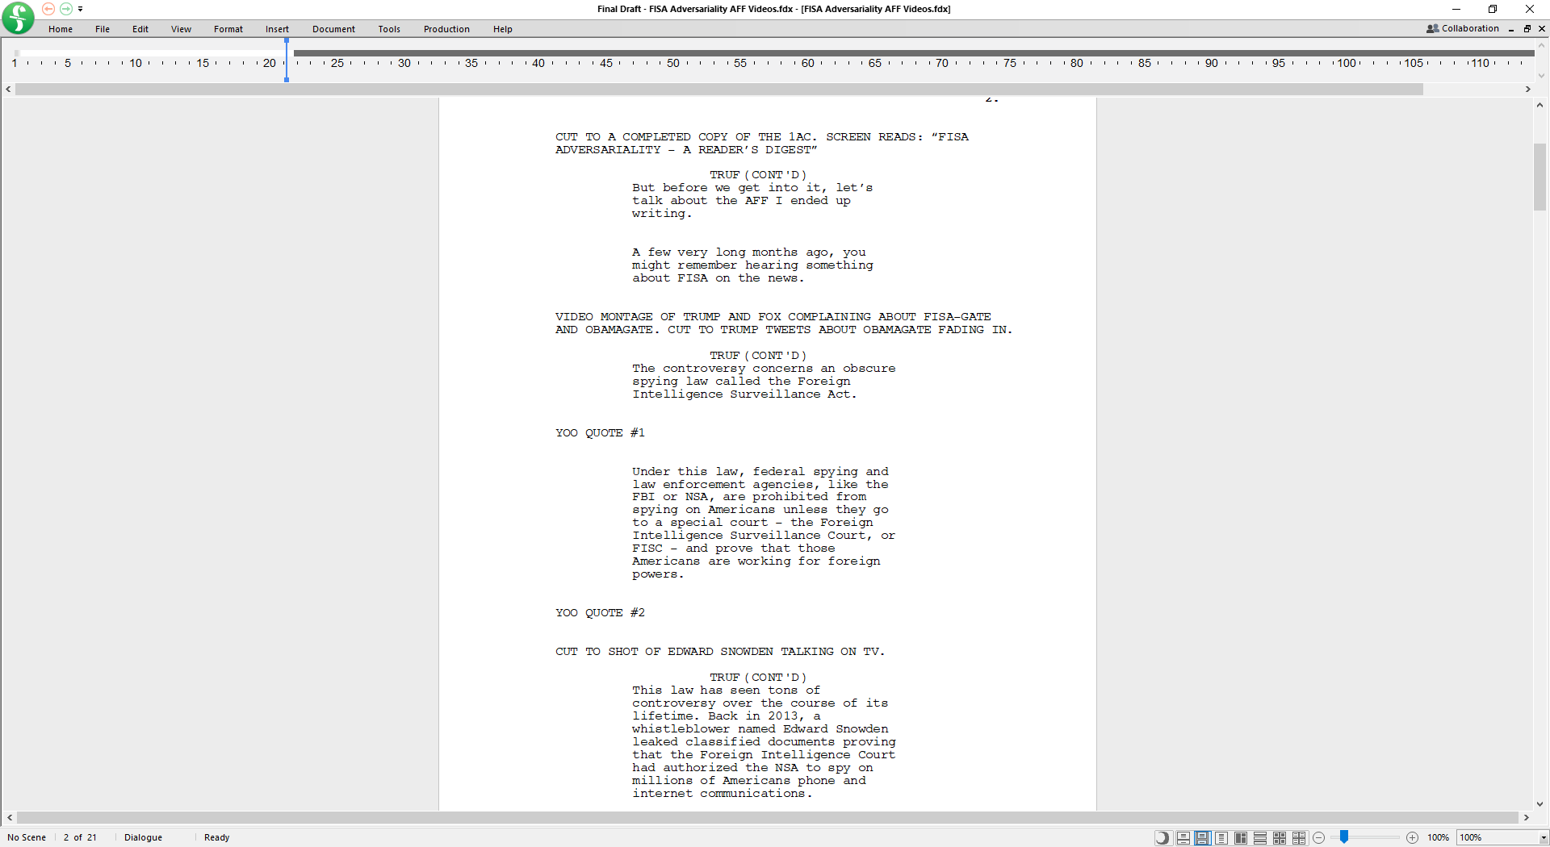

6. Have a pre-packaged intro-outro that is applied to all videos. This provides unity, branding, and professionalism.

7. Music. Every video should have some background music playing, softly. Every good YouTube video you’ve ever seen has it. The absence of music accentuates imperfections in your narration and makes pauses boring and conspicuous. You always want something to be going on, both with sound and with video. Music will seem weird at first. As long as your music is part of the background it will fit into your video naturally.

8. Use free tools. There are tons of graphics packages, stock footage websites, stock soundtrack websites, and royalty free music resources that you can draw upon without paying anyone anything. There are also free tools for making fancy thumbnails, like bannersnack.com

9. Fiverr is a website you can use to pay people to do projects for you. It can be incredibly cheap depending on what you want them to do. Good way to offload editing busywork if you don’t want to do it.

10. Uploading videos to Google Drive or YouTube and sending links is the fastest way to transfer video files.

11. YouTube final touches. Make more than one video before uploading anything. Have an end screen that links to other videos you have made. Make a thumbnail that makes your video look interesting. Put your logo as a watermark in the corner.

12. Give time to digest information. If you have a visual, make sure it’s up on the screen long enough for the viewer to read it, and talk over it (there were a few places where I whiffed on this).

13. Recap at the end. This may seem unnatural considering that it’s a video and they can just rewind, but the ideal way for a video to be consumed is for people to simply watch it beginning to end. Hammering home the key points at the end of your video can help.

14. Keep your media on your computer’s hard drive, rather than on an external drive, if possible. This will make the preview render faster so you can get a better idea of what your video looks like before you export.

15. The best export settings. Format should be H.264 – that is what they call mp4s for some reason. The Preset should be YouTube 1080p Full HD. Everything else should stay default.

1.5 Concluding Thoughts
I hope this was helpful in breaking down the basics of producing a video. I think in the online camp format it will be important to experience with alternative mechanisms of delivering information. Lectures have always been a fraught format, with most people (including myself) largely unable to overcome their essentially boring nature through sheer force of personality. Coupled with the well-known phenomenon of Zoom fatigue playing a critical role in camp scheduling discussions, this consideration should drive us as a community to look into alternative means of delivering information to younger generations.

Videos are short, they are rewatchable, and they are asynchronous – all major advantages over lectures. But they are also just one idea of many that we can consider as a community. I hope this summer gives us all an opportunity to innovate in a way that can deliver lasting improvements to the established camp formula.

